7.a

Course Name: Express.js

Module Name: Defining a route, Handling Routes, Route Parameters, Query Parameters Implement routing for the AdventureTrails application by embedding the necessary code in the routes/route.js file.

Program:

var express = require('express');

var app = express();

app.get('/', function (req, res) {

console.log("Got a GET request for the homepage");

res.send('Welcome to MST lab');

})

app.post('/', function (req, res) {

console.log("Got a POST request for the homepage");

res.send('I am Impossible! ');

})

app.delete('/del_student', function (req, res) {

console.log("Got a DELETE request for /del_student");

res.send('I am Deleted!');

})

app.get('/enrolled_student', function (req, res) {

console.log("Got a GET request for /enrolled_student");

res.send('I am a MST student');

})

// This responds a GET request for abcd, abxcd, ab123cd, and so on

app.get('/ab*cd', function(req, res) {

console.log("Got a GET request for /ab*cd");

res.send('Pattern Matched.');

})

var server = app.listen(8000, function () {

var host = server.address().address

var port = server.address().port

console.log("Example app listening at http://%s:%s", host, port)

})

Output:

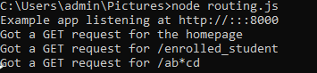

http://localhost:8000/

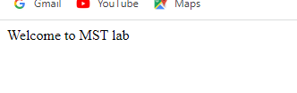

http://localhost:8000/enrolled_student

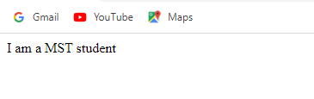

http://localhost:8000/ab*cd

